**Assessment 3 HTML Website Design (8936)  
A Small Business Guide**

Student ID: u3311230 • Email: u3311230@uni.canberra.edu.au

# 1. Overview

This site guides a new founder from idea to first customer. It follows the required wireframes and map, uses a left sidebar navigation without hover effects, and implements dark/light themes, forms, images, lists, tables, symbols and JavaScript apps for interactivity. Colours are specified in hexadecimal.

# 2. Topic & Pages

Topic chosen from list: A Small Business Guide. Required pages present and correctly named:

* Main.html (wireframe A)
* validate.html (Choice 1)
* market.html (Choice 2)
* brand.html (Choice 3)
* money.html (Choice 4)
* ops.html (Choice 5)
* legal.html (Choice 6)
* Contact.html
* References.html
* MetaPage.html

# 3. Website Map

Navigation follows the provided map: core links (Main, Contact, Meta, References) and pathway links (Choices 1–6).

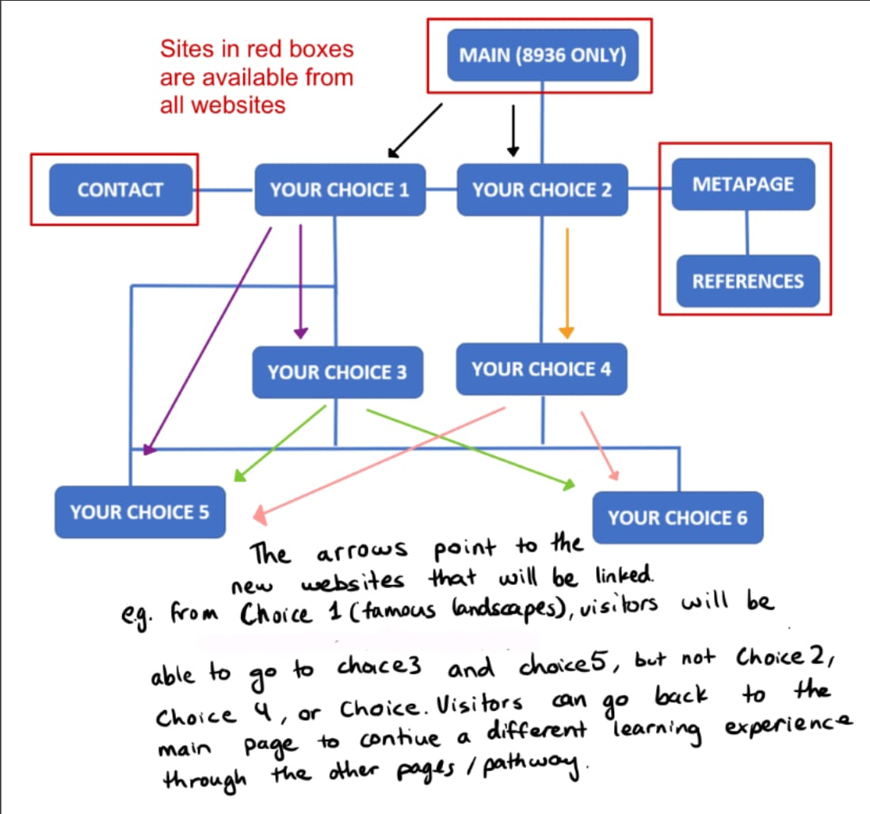

# 4. Wireframes

Wireframe (a) for Main, Wireframe (b) for all other pages. The layout respects header, left nav, main and footer.

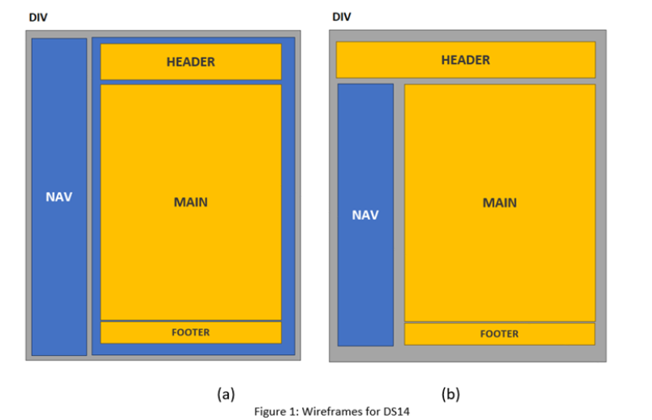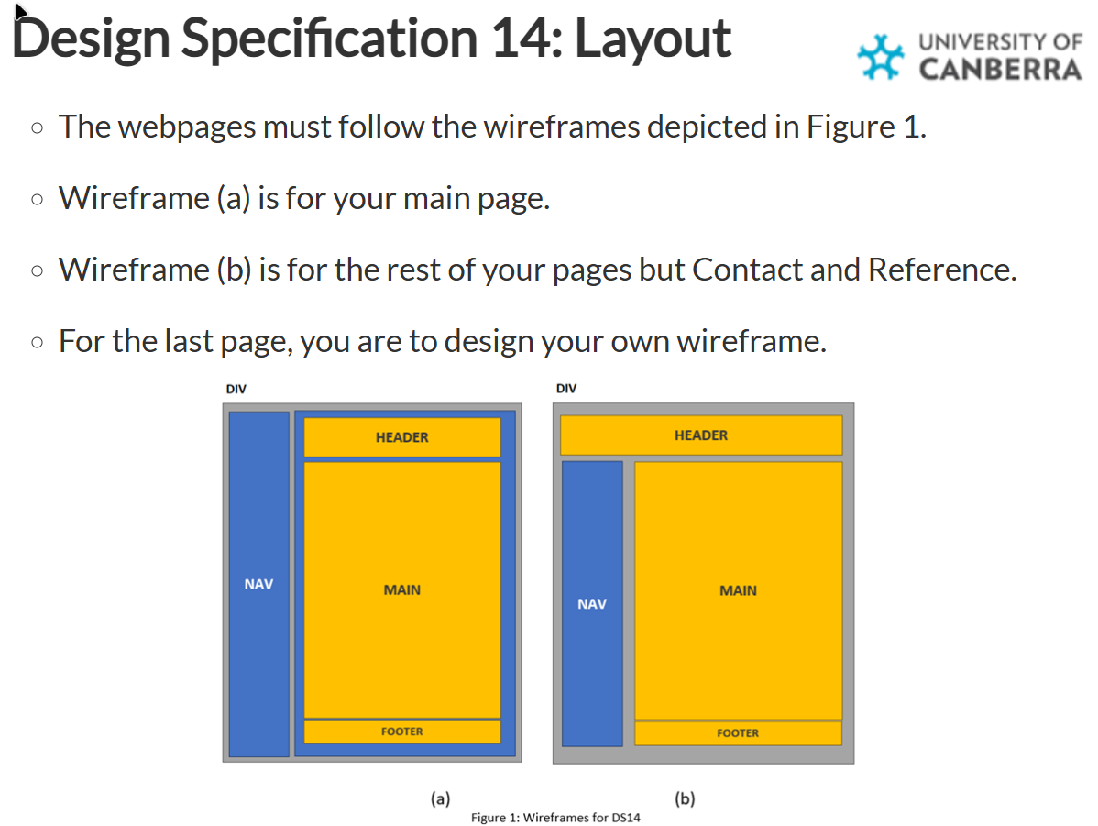

# 5. Features & JavaScript

Implemented features include:

* Lists: unordered, ordered and description lists
* Writing elements: line break, block quote, phrase/emphasis
* Tables (3 types) with align/width/border/cellpadding/row/col spans
* Symbols (UTF‑8) throughout
* Functional contact form (mailto prefill)
* JavaScript mini‑apps: validation planner, positioning statement, brand brainstorm, unit‑economics calculator, SOP builder, legal checklist

# 6. CSS Styling & Selectors

Inline, embedded and external CSS used. All colours in hex. External file defines class and ID selectors. The theme toggle persists preference in localStorage. No hover effects are used.

# 7. Validation Evidence

Nu HTML Checker and W3C CSS Validator screenshots (no errors or warnings):

* Main.html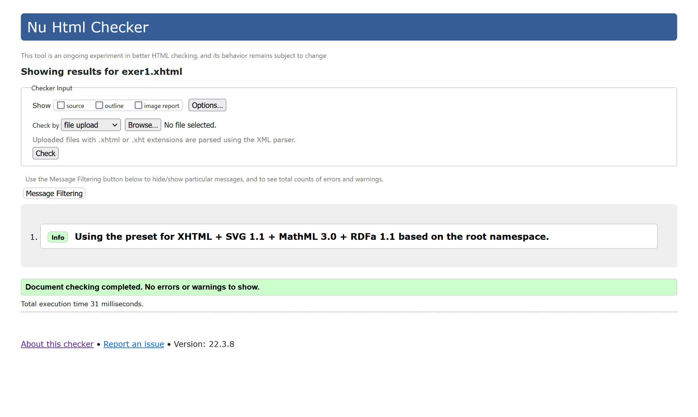
* Brand.html

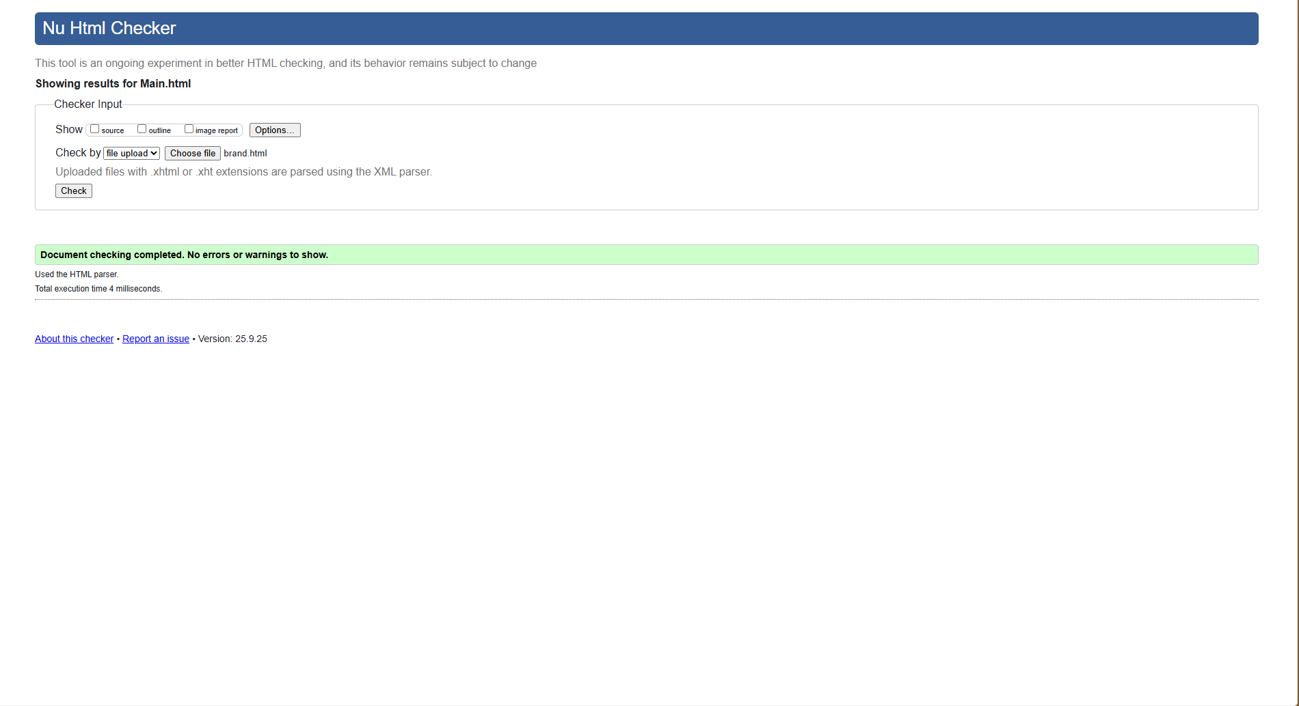

* Contact.html

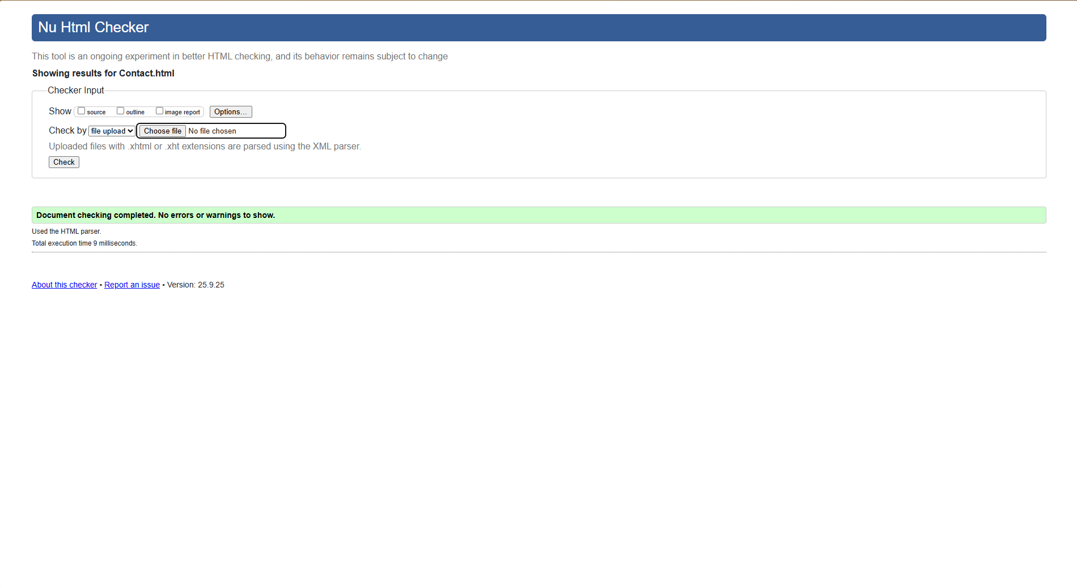

* Legal.html

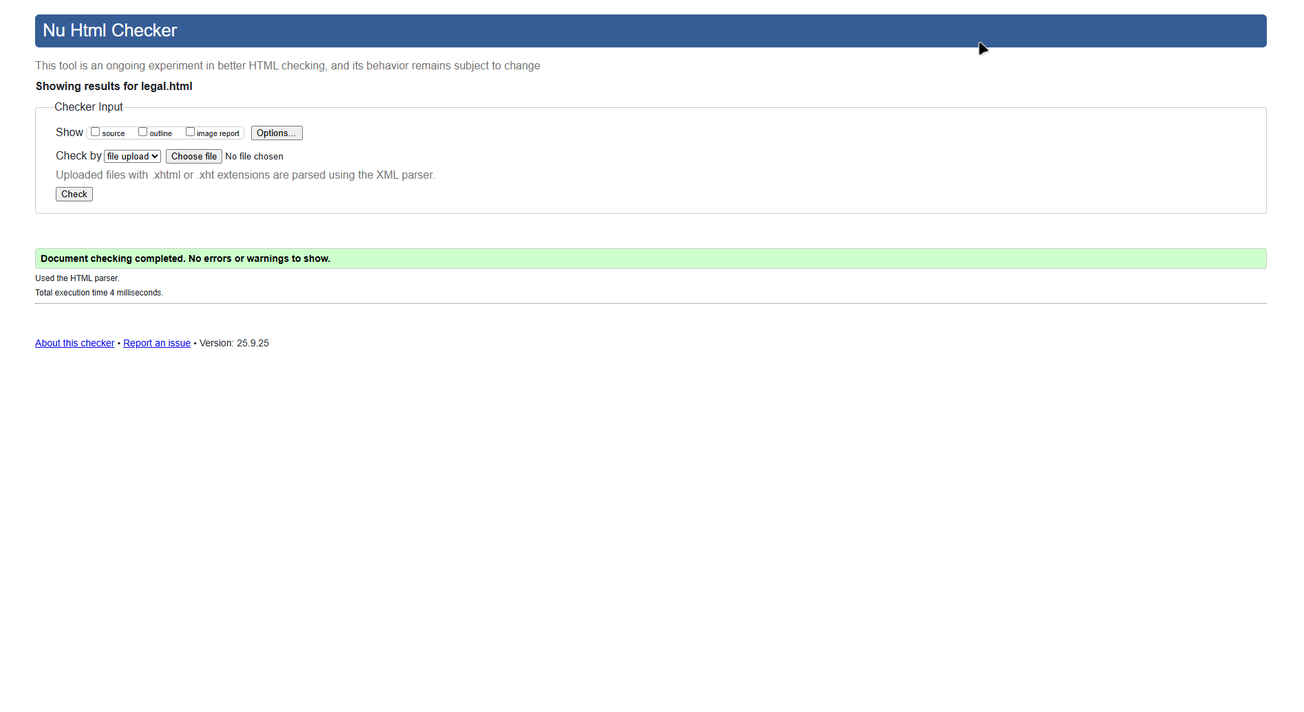

* Market.html

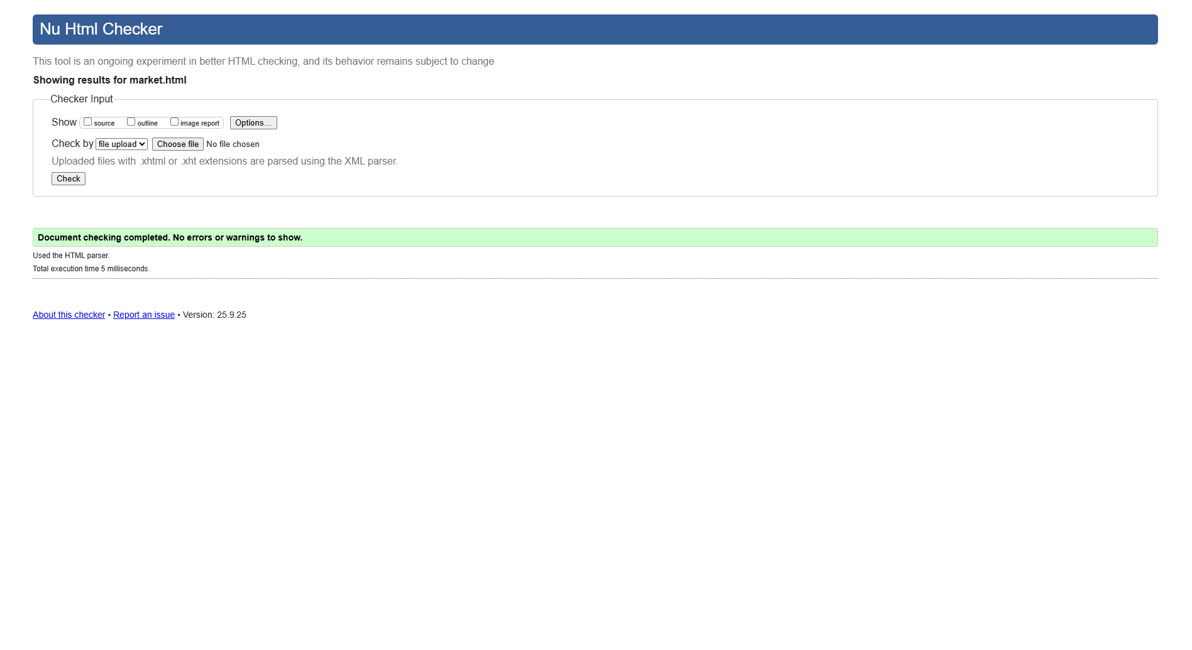

* MetaPage.html

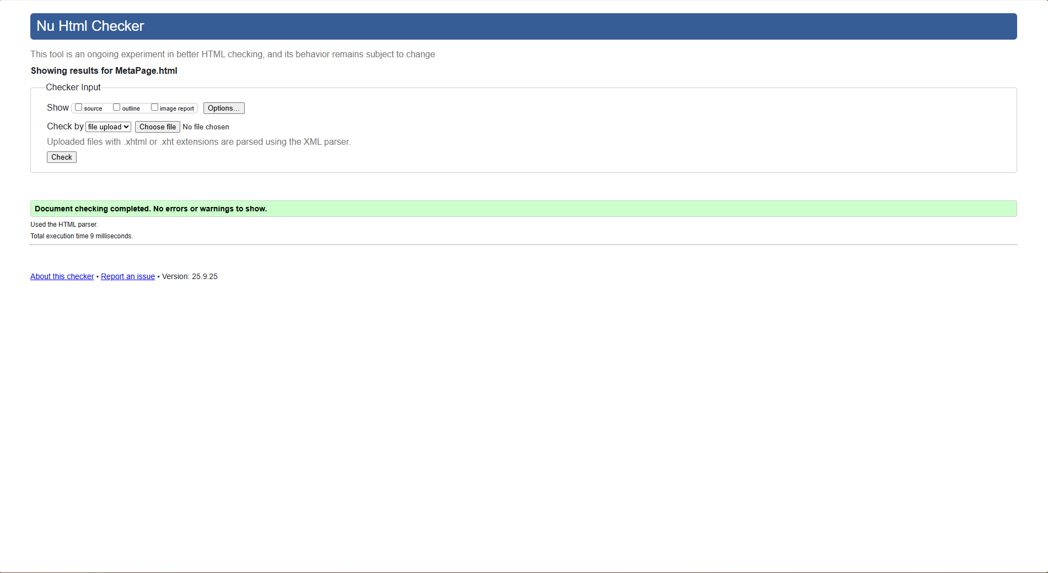

* Money.html

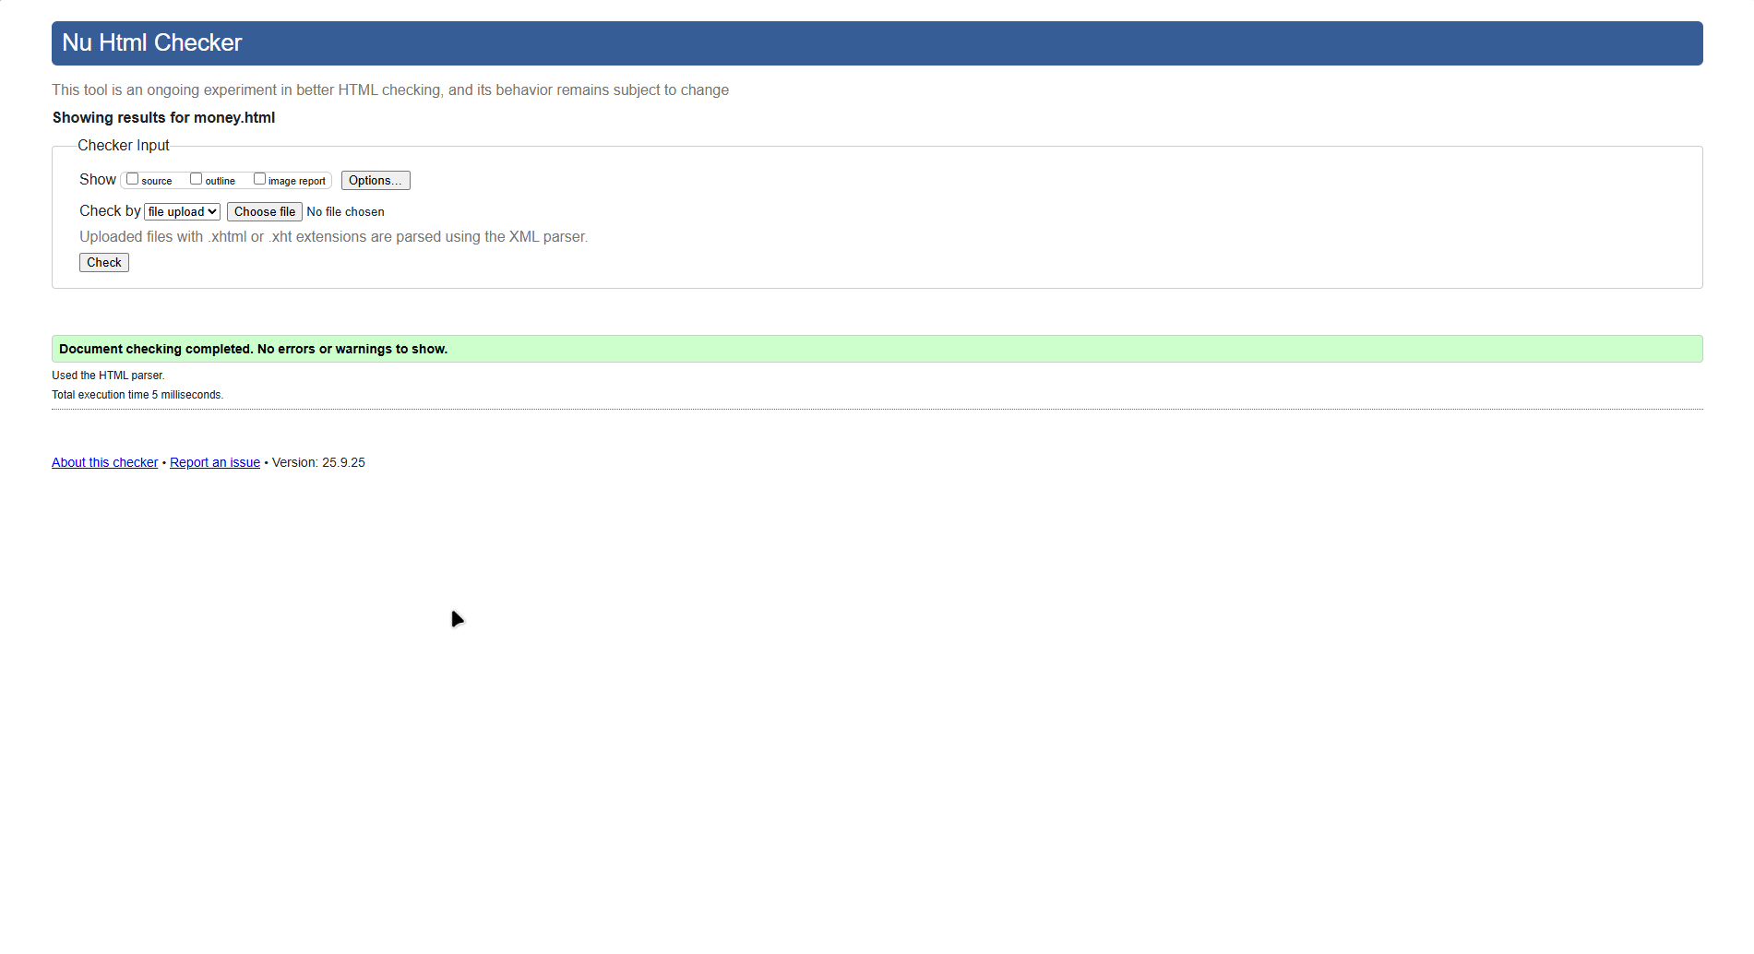

* Ops.html

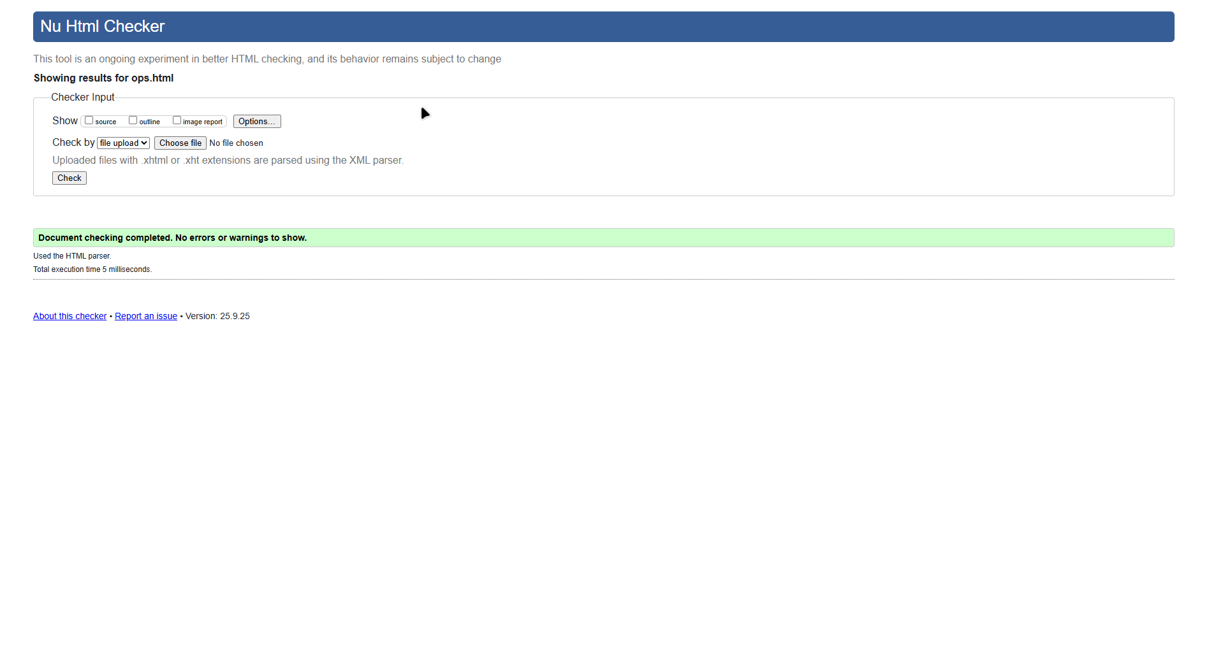

* References.html

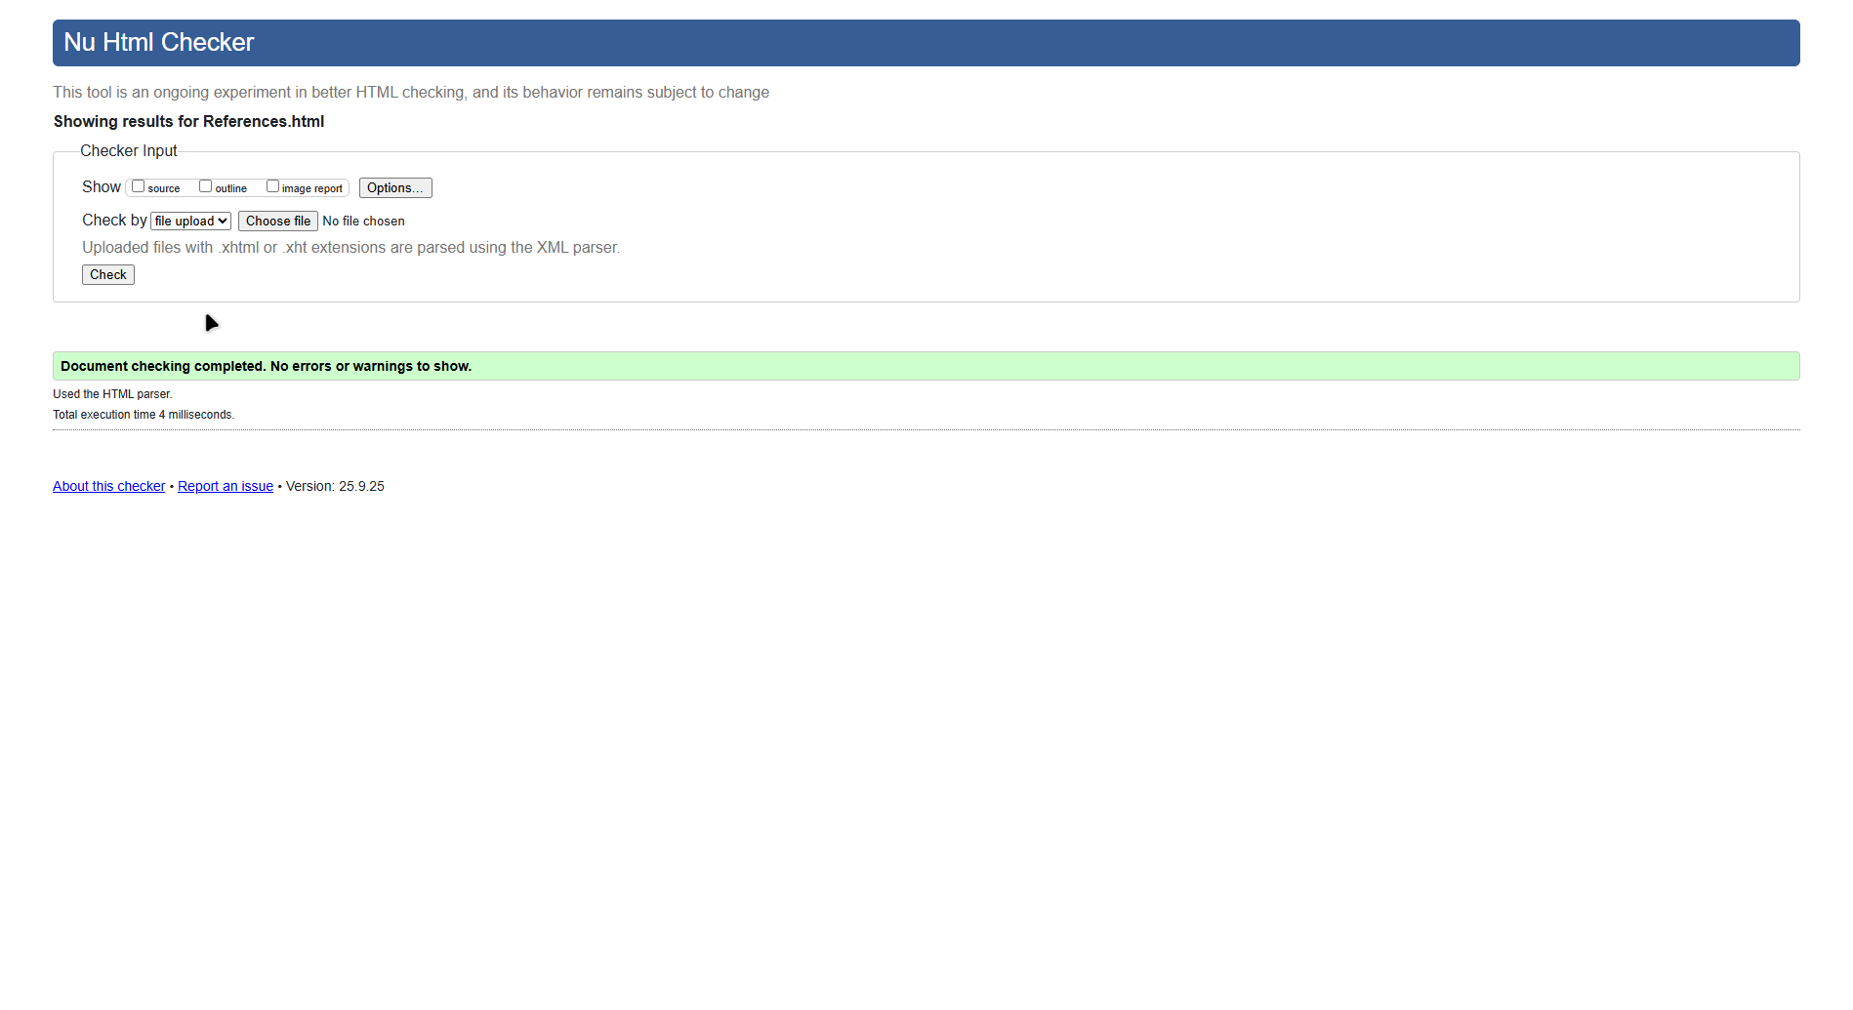

* Validate.html

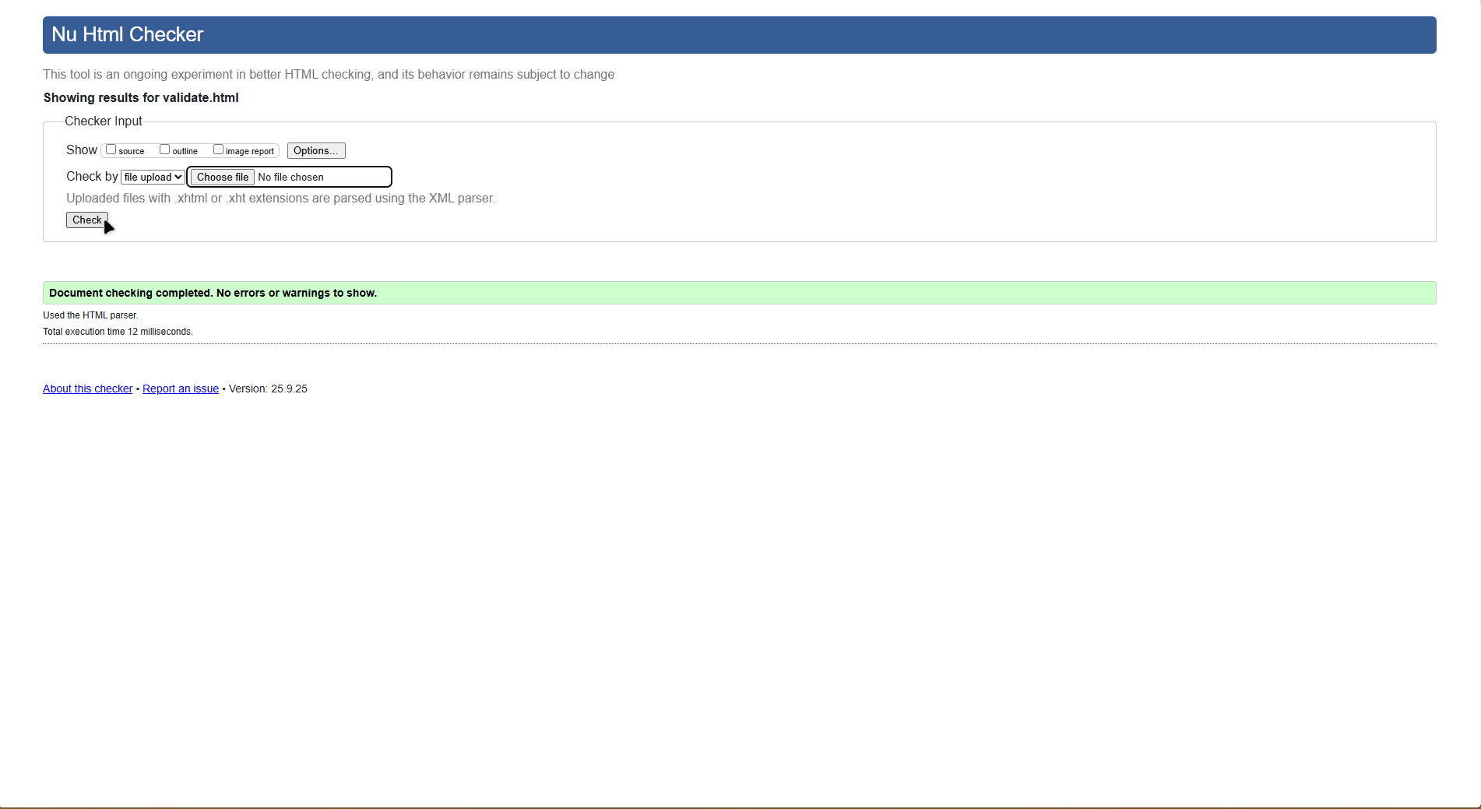

* styles.css

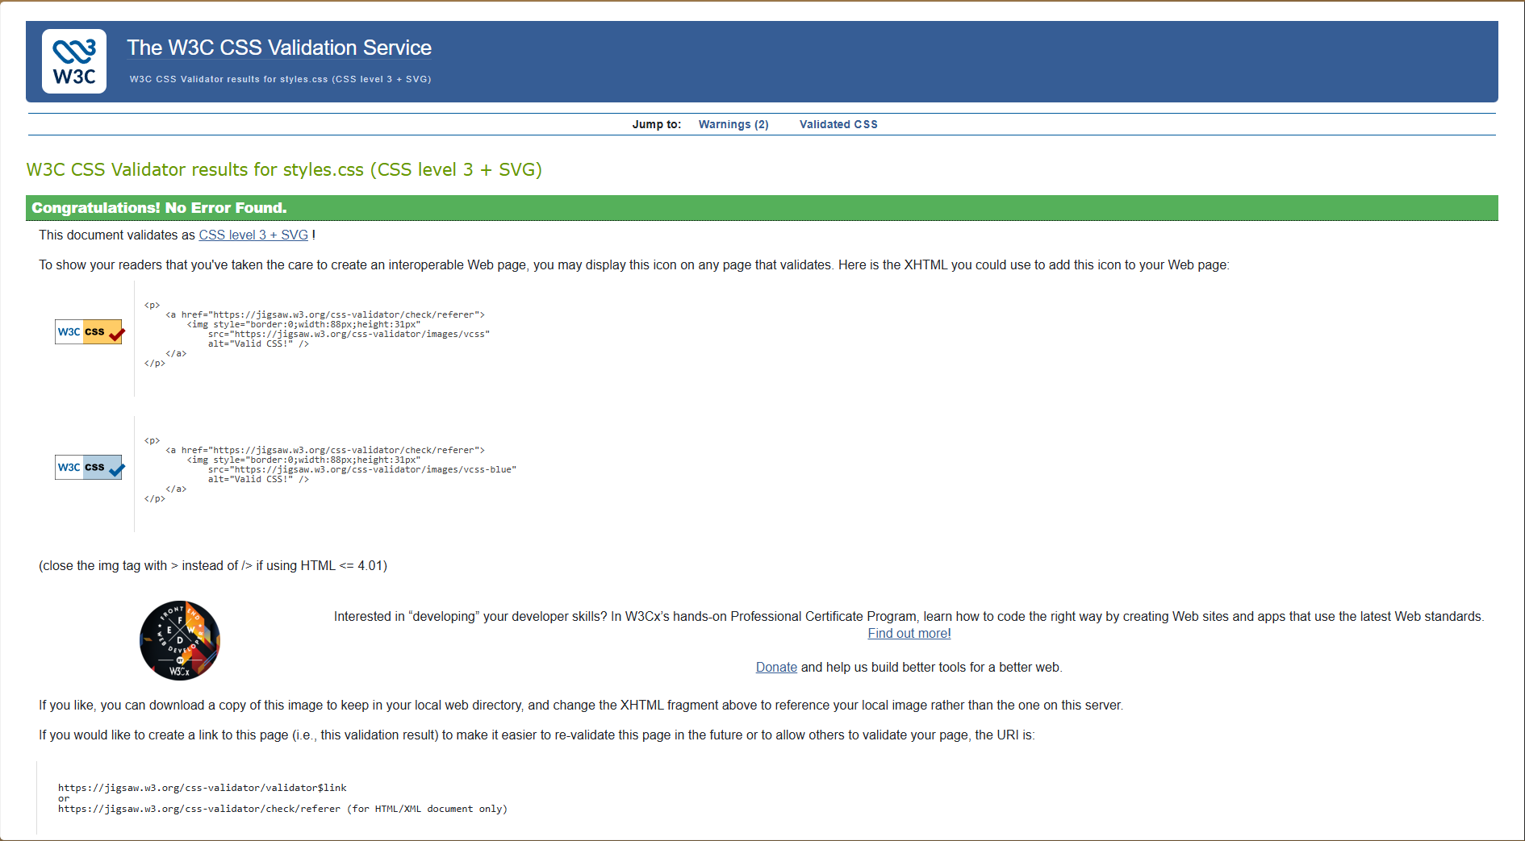

# 8. References (Harvard 2021)

1. Australian Government 2025, business.gov.au: Start a business guide, viewed 2025, <https://business.gov.au>
2. Australian Securities & Investments Commission (ASIC) 2025, Register a company, viewed 2025, <https://asic.gov.au>
3. Australian Taxation Office (ATO) 2025, GST and small business, viewed 2025, <https://ato.gov.au>
4. OECD 2024, Entrepreneurship at a Glance, OECD Publishing, Paris.
5. Harvard Business Review 2023, Customer discovery done right, HBR, Boston.
6. Use of generative AI 2025, Assisted drafting of copy and code for this assignment.